

# BOM Flow

# Application Help

Application -> Masters -> BOM Management

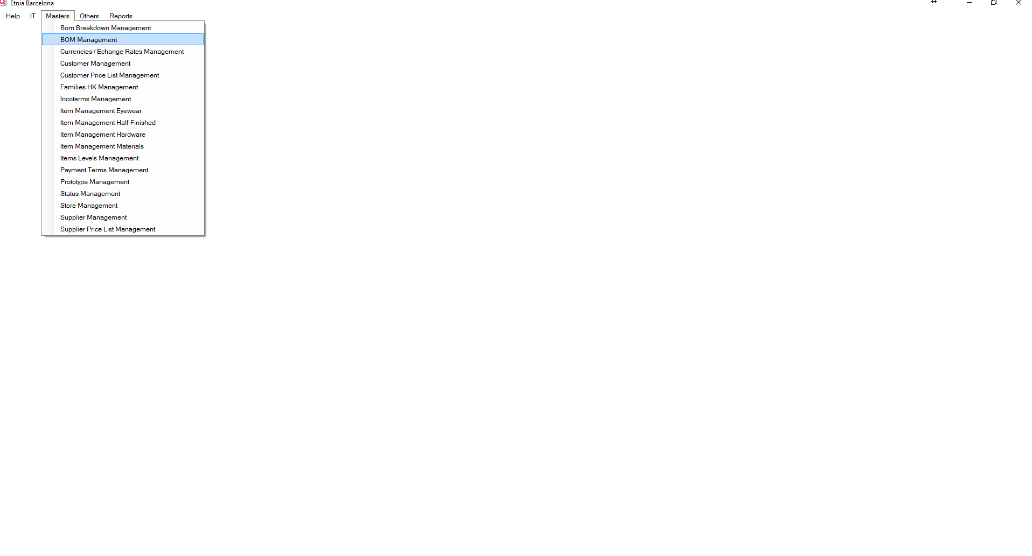

Figure 1: BOM Management Menu

## BOM Display Mode

### Initial window

Right Panel: Items list and Half-finished list group by

* Family
  + Model
    - Supplier/Factory

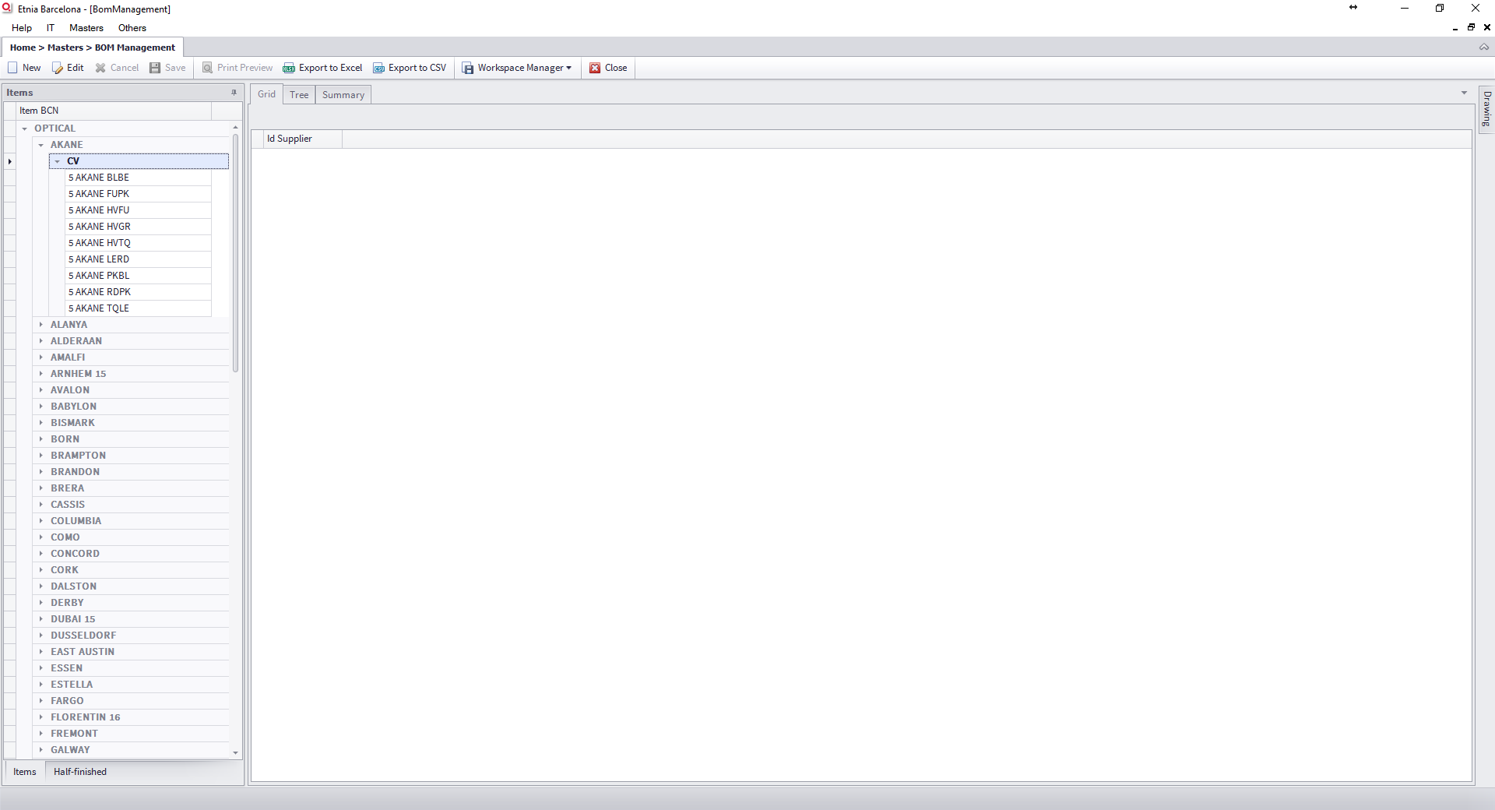

Figure 2: BOM Management Initial Window

Double click on item to see the BOM detail.

### Grid Tab

In the this tab you can see the BOM for each defined supplier. Only the default supplier is expanded.

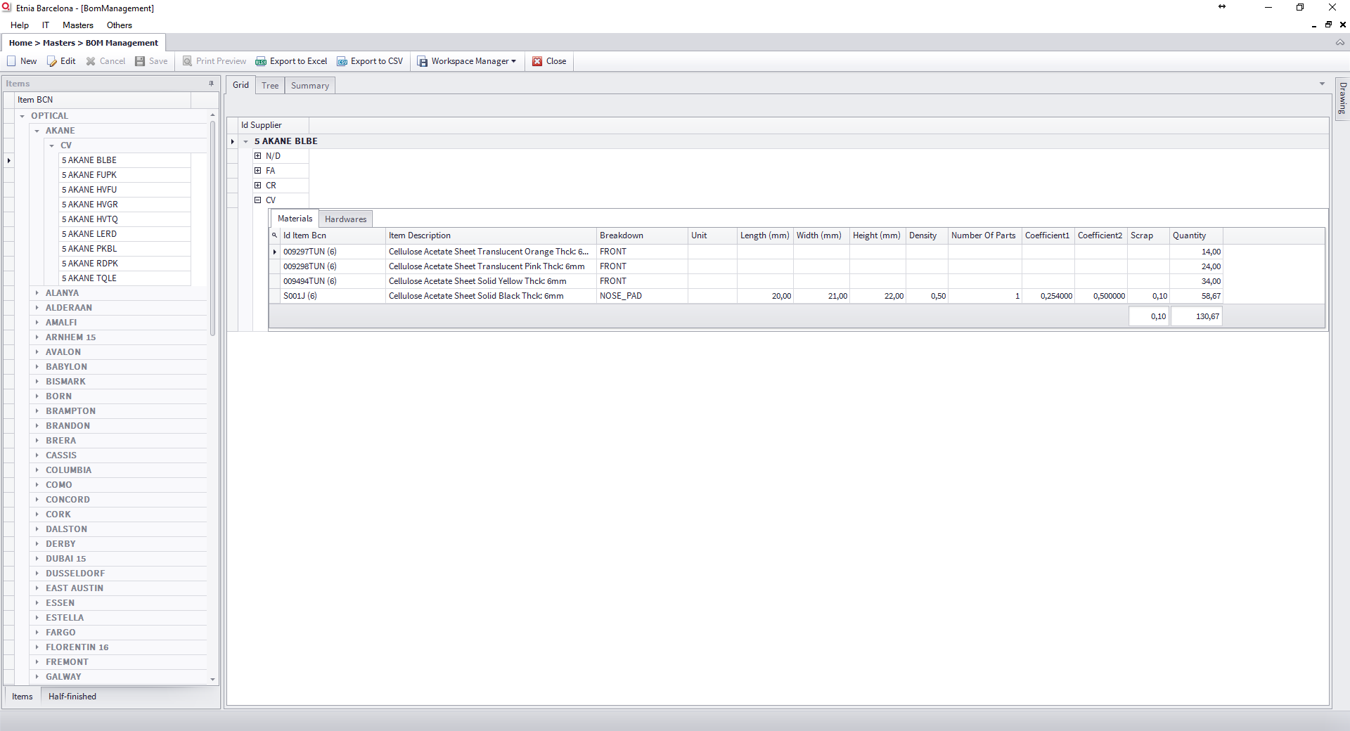

Figure 3: Item BOM main detail tab

### Tree Tab

In this tab you can see the tree view.

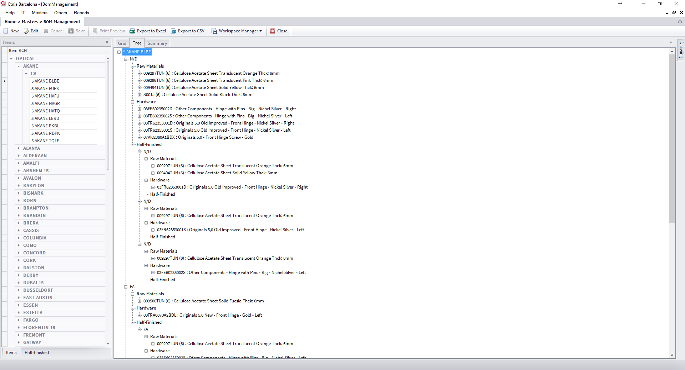

Figure 4: Item BOM tree view tab

### Summary Tab

In this tab you can the summary

* Summary by item/supplier
* Summary by unit/supplier

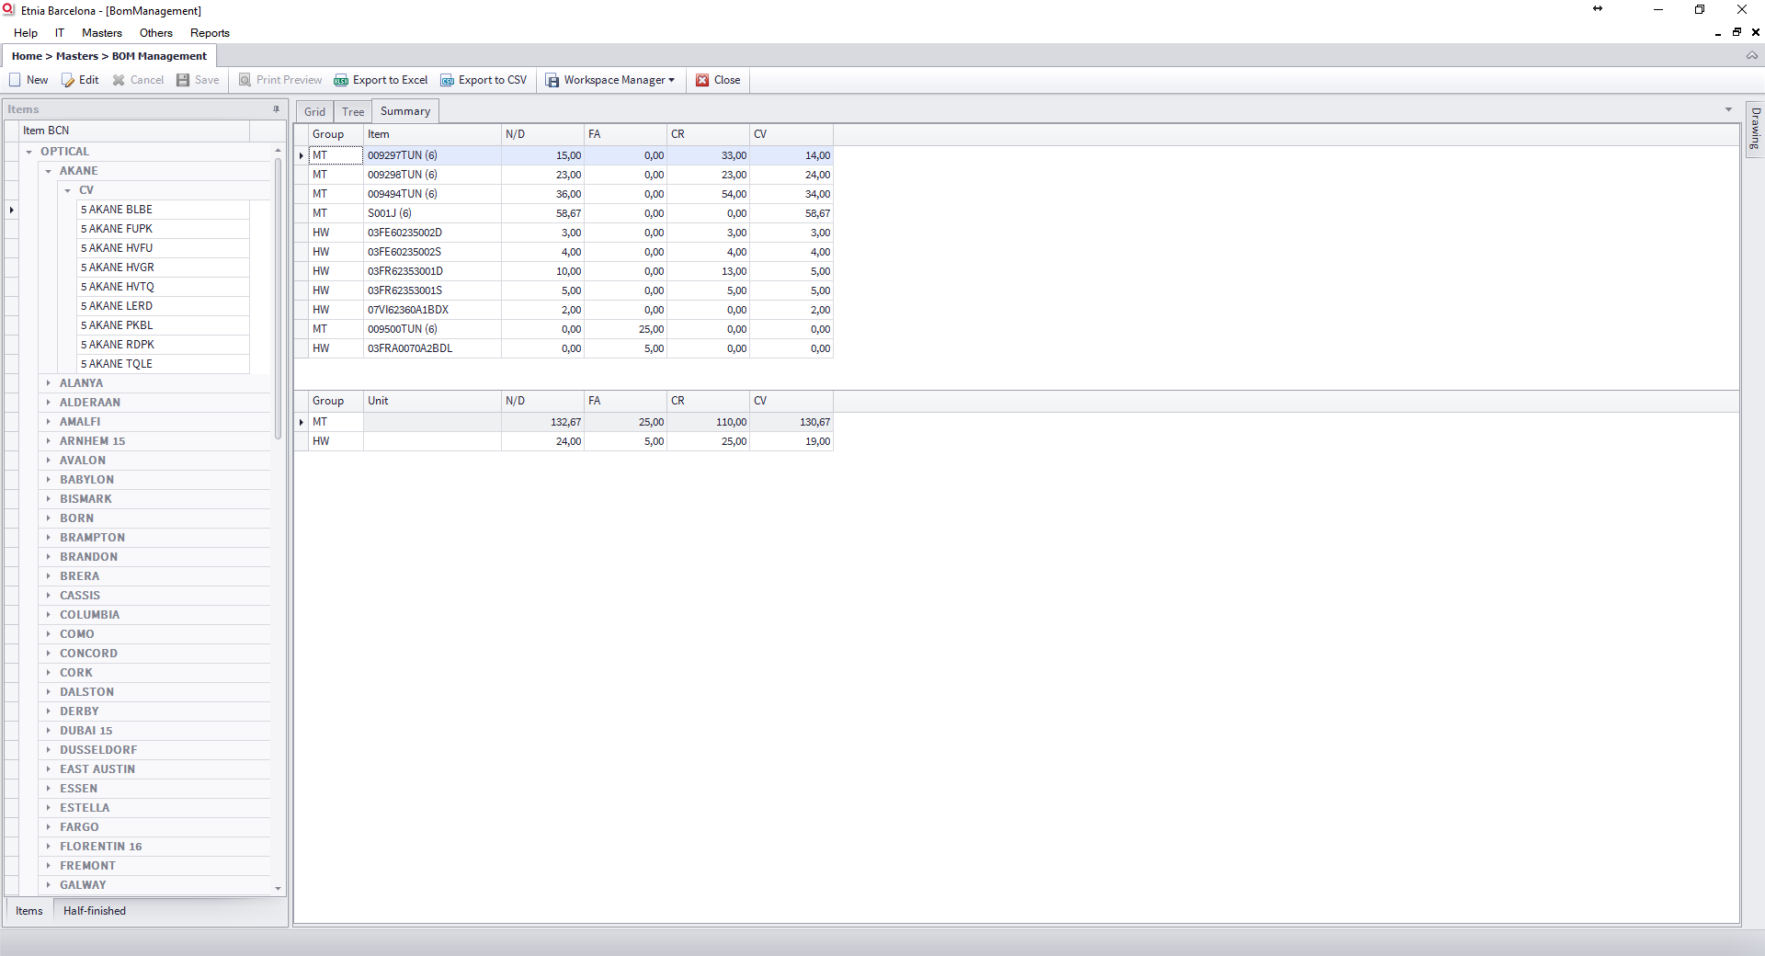

Figure 5: Item BOM Summary tab

### Drawing panel

At the right of the screen you can see the Drawing Panel, it is hidden, but you can see it if mouse is over. It is a resizable panel and you can pin it, move it or add it as a tab to main control.

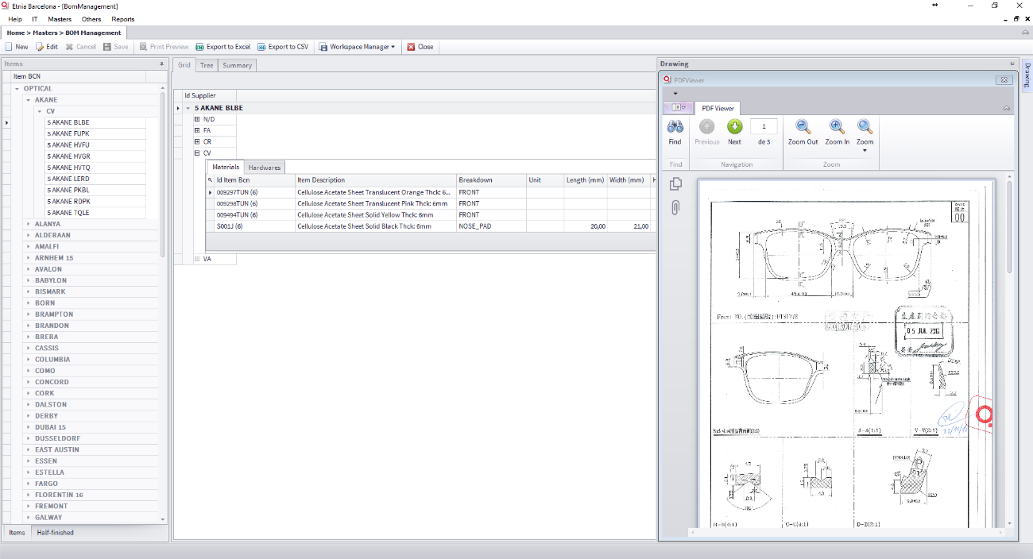

Figure 6:Drawing panel as docking panel

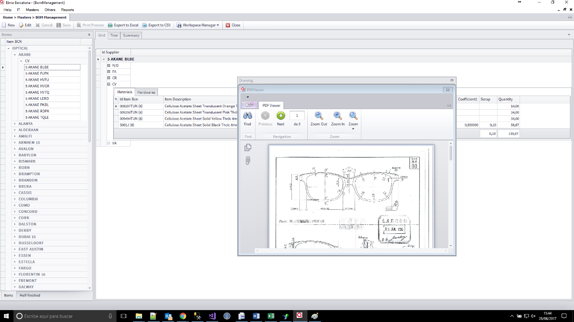

Figure 7:Drawing panel as floating panel

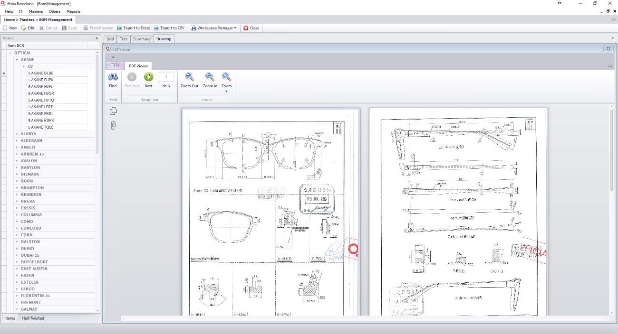

Figure 8: Drawing panel as tab

## BOM Edit Mode

To edit BOM, click on Edit in toolbar, the left panel will hide and the buttons to add new supplier and copy a BOM for one supplier to another will appear.

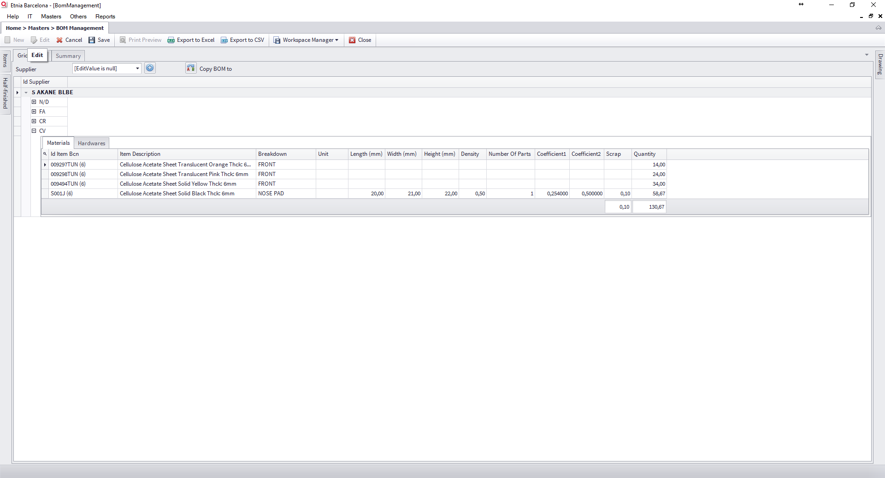

Figure 9: Item BOM edit mode

### Add New Supplier

If you want to add a new supplier select one in the list and click on the button, it will appear in the BOM list, but empty.

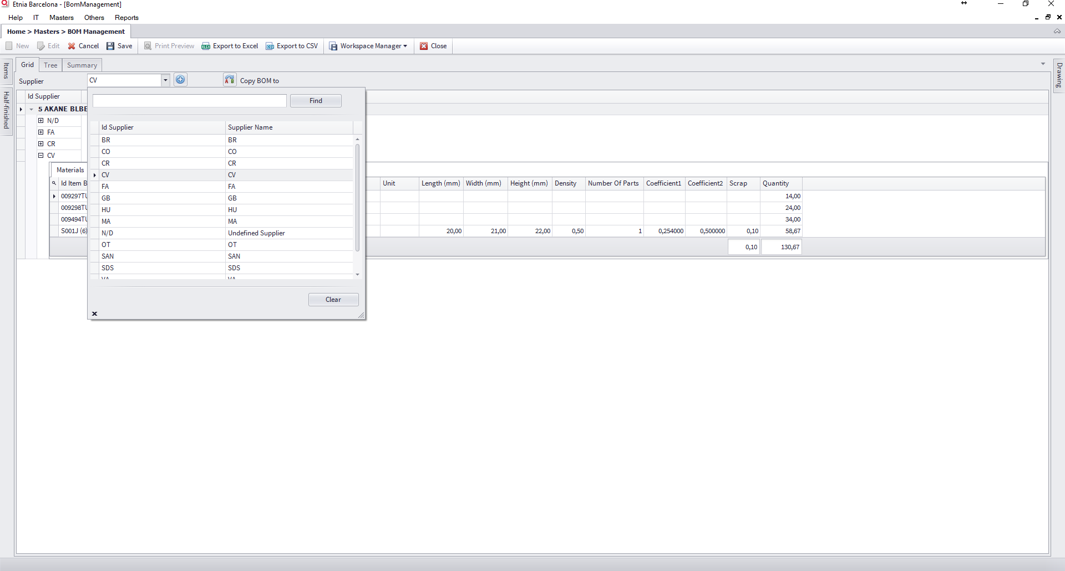

Figure 10: BOM edit, add new supplier

### Add Materials, Hardware or Half-finished First Time

If you want to add Materials, Hardware or Half-finished for the first time, right click over the supplier name and select one in the list options.

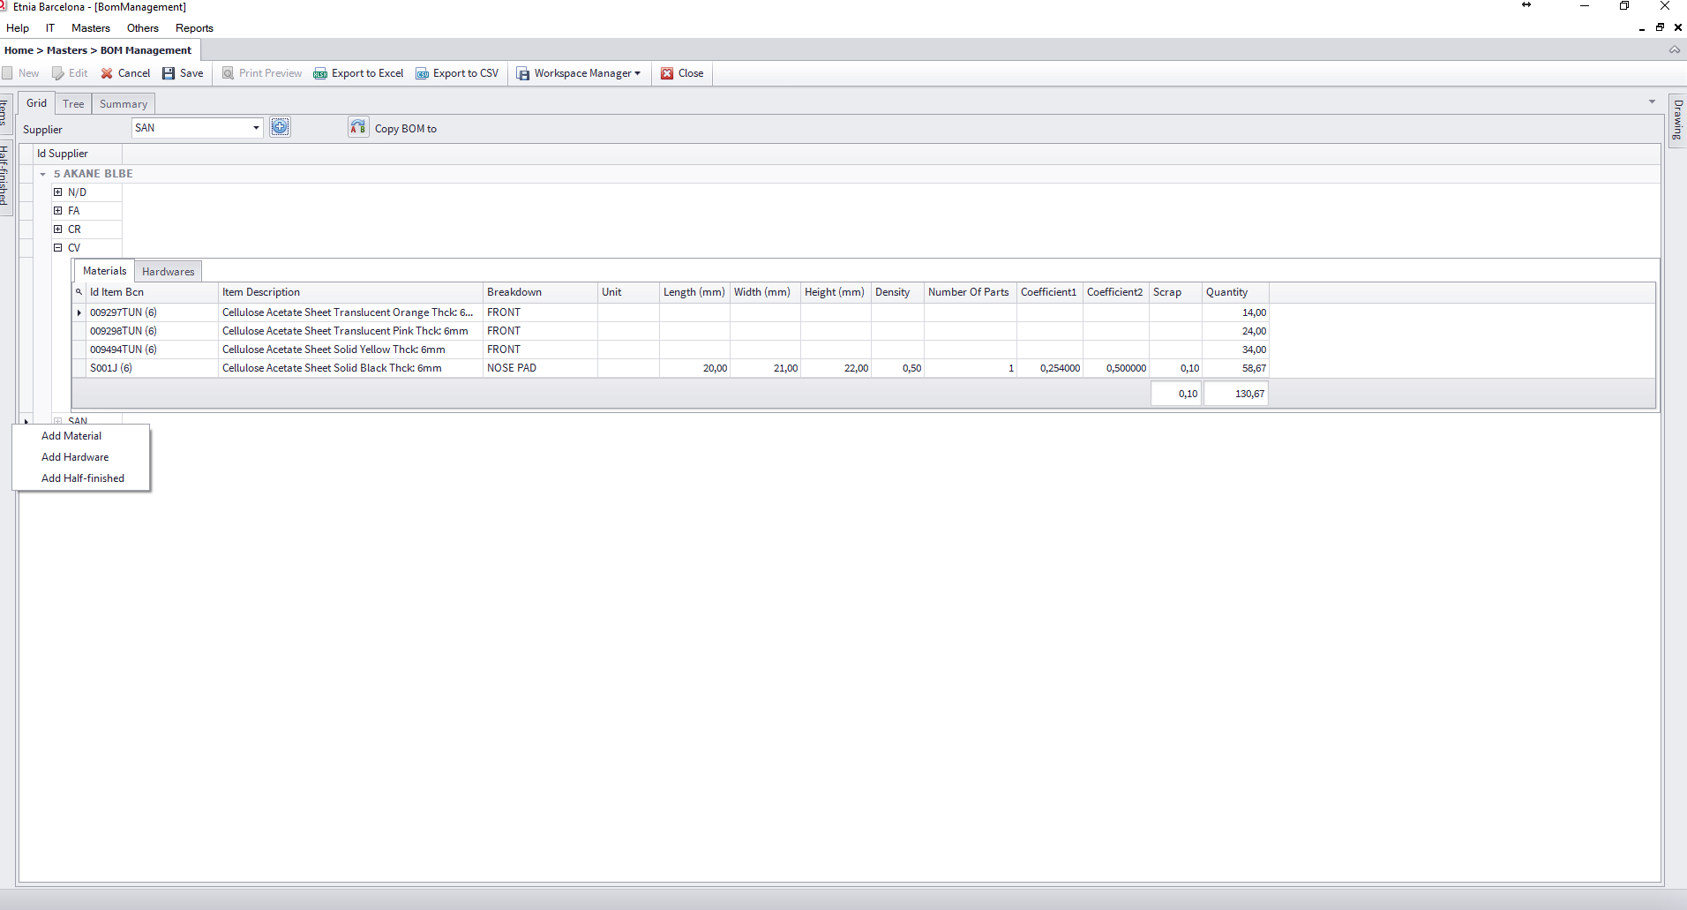

Figure 11: Edit BOM, add Material/Hardware/Half-finished first time

### Edit Materials

You can select a material and a breakdown from the list. For quantity, there are two options, you can fill the fields “Length”, “Width”, “Height”, “Density”, “Number of parts”, “Coefficient 1”, “Coefficient 2”, “Scrap” and the application calculate the Quantity or you can fill directly the quantity, but you can’t indicate any other value. At the end, press Enter for a new line.

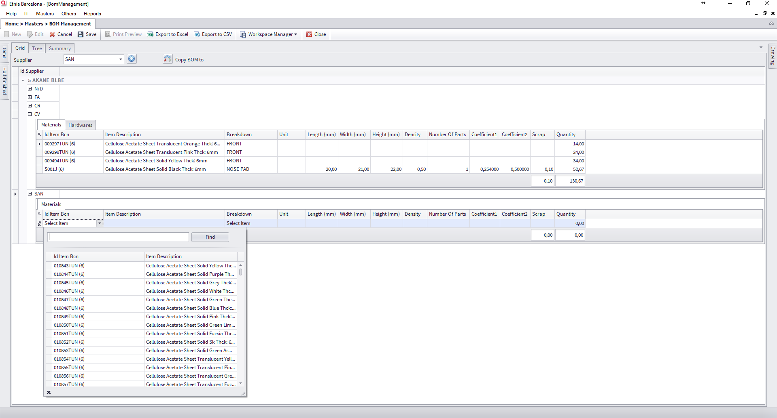

Figure 12: Edit material, select material item

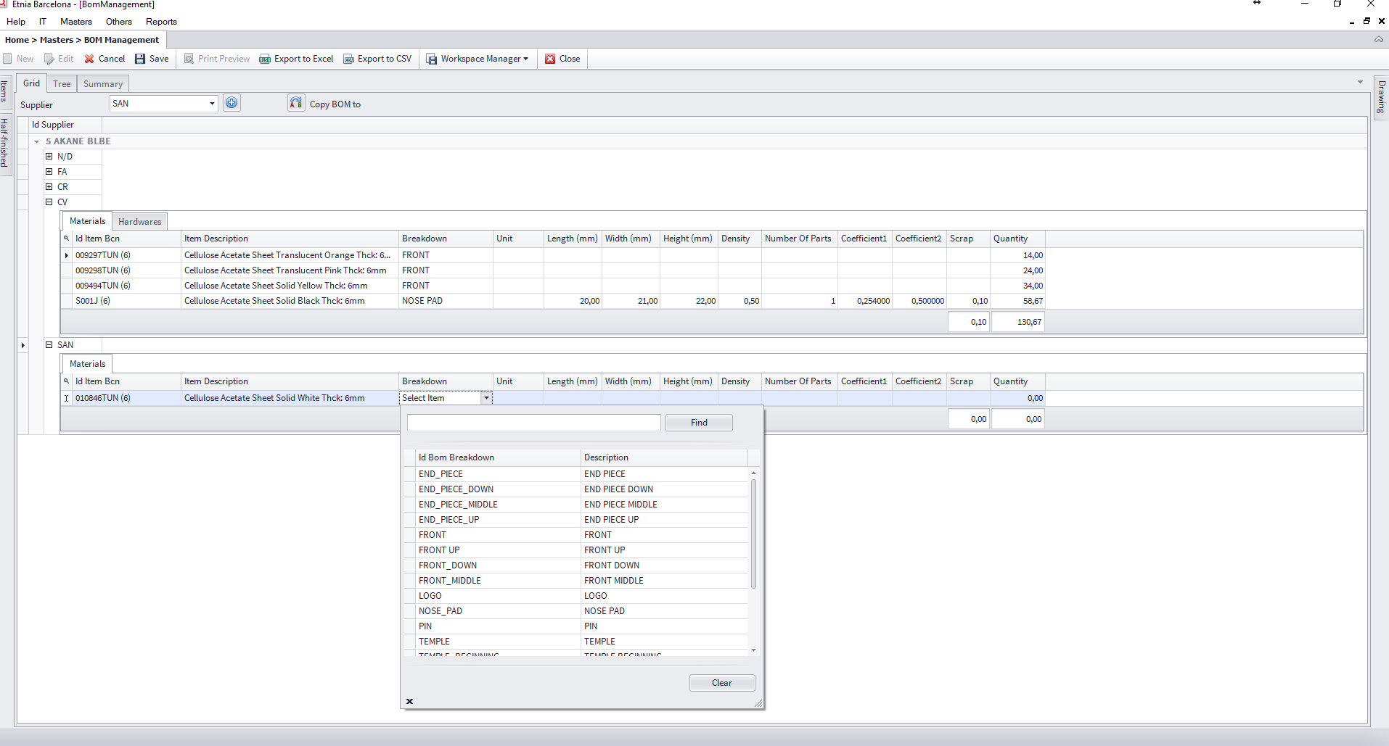

Figure 13:Edit material, select material breakdown

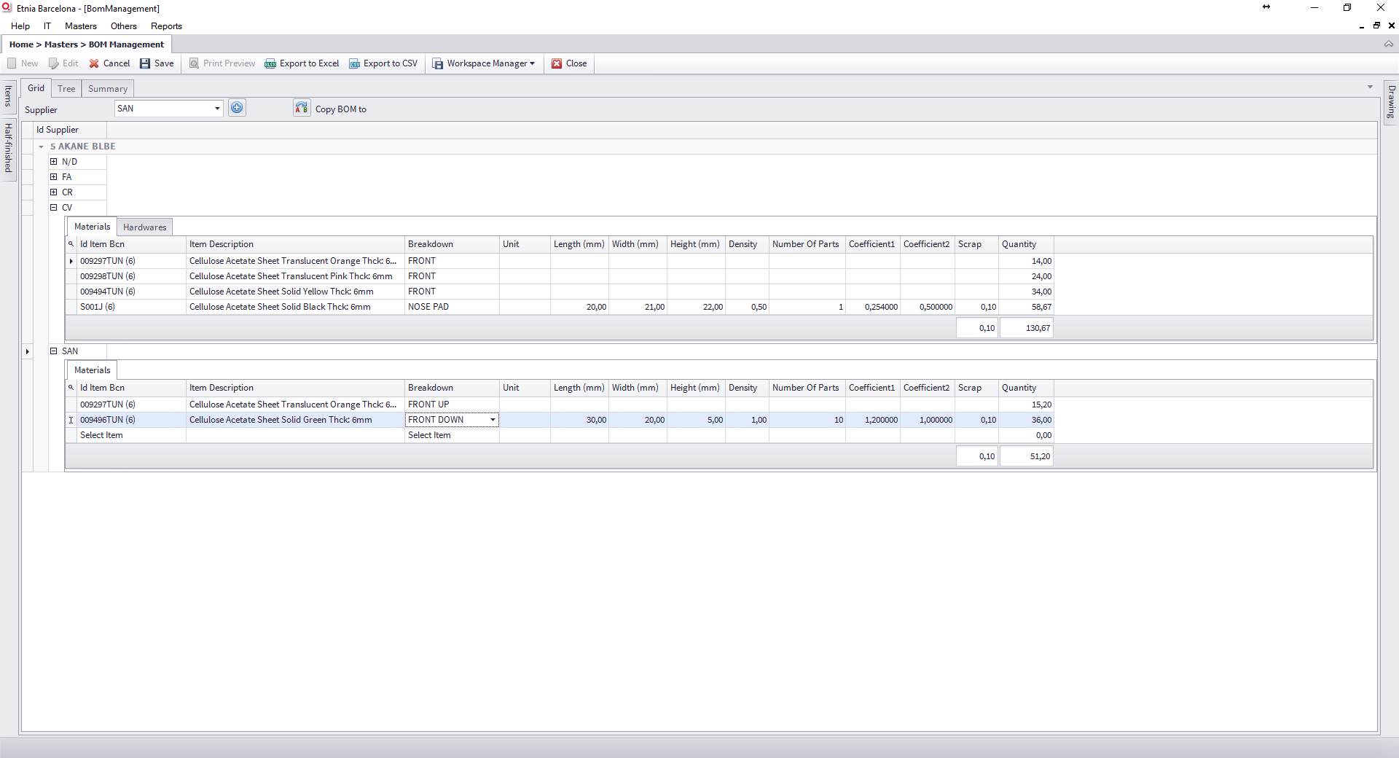

Figure 14Edit materials, new lines

### Edit Hardware

You can select a hardware and a breakdown from the list and fill scrap (not mandatory) and quantity. At the end, press Enter for a new line.

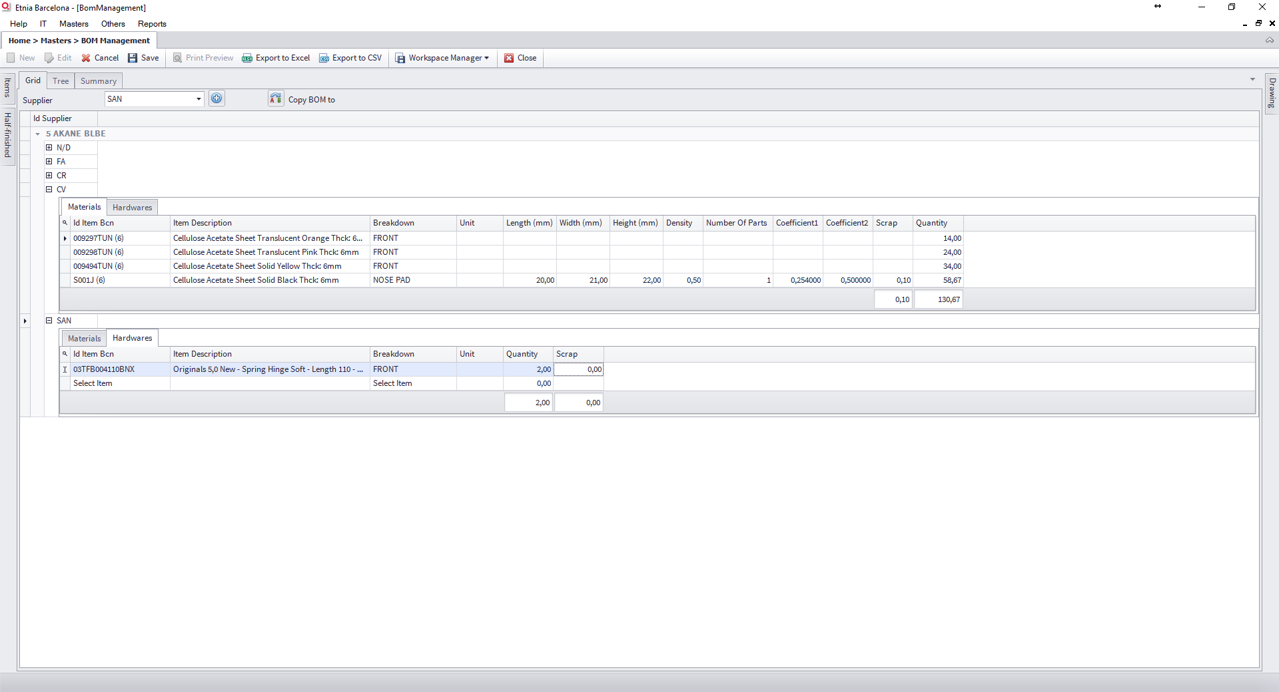

Figure 15: Edit hardware, new line

### Edit Half-finished

You can select a half-finished and fill quantity. At the end, press Enter for a new line.

Note: In half-finished list only appear the half-finished who had a BOM defined for this supplier.

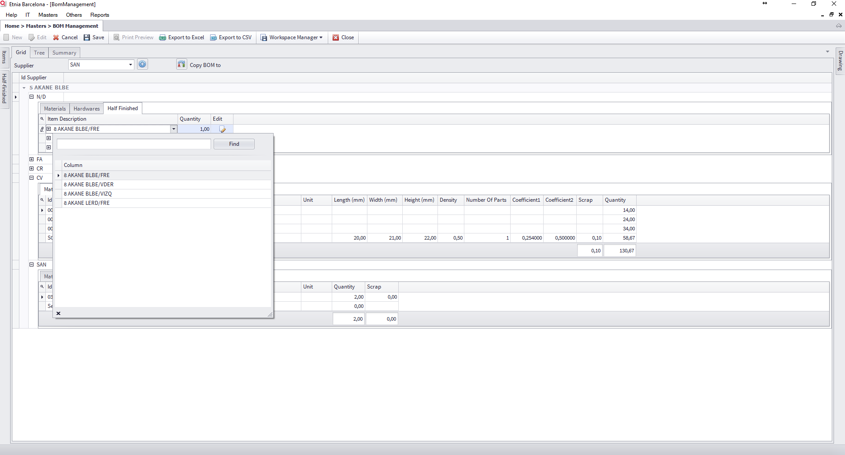

Figure 16: Edit half-finished

### Copy supplier BOM to another supplier

It is possible to copy one supplier BOM to another supplier. If you click to “Copy BOM to”, you can select the supplier BOM source and the destination or destinations.

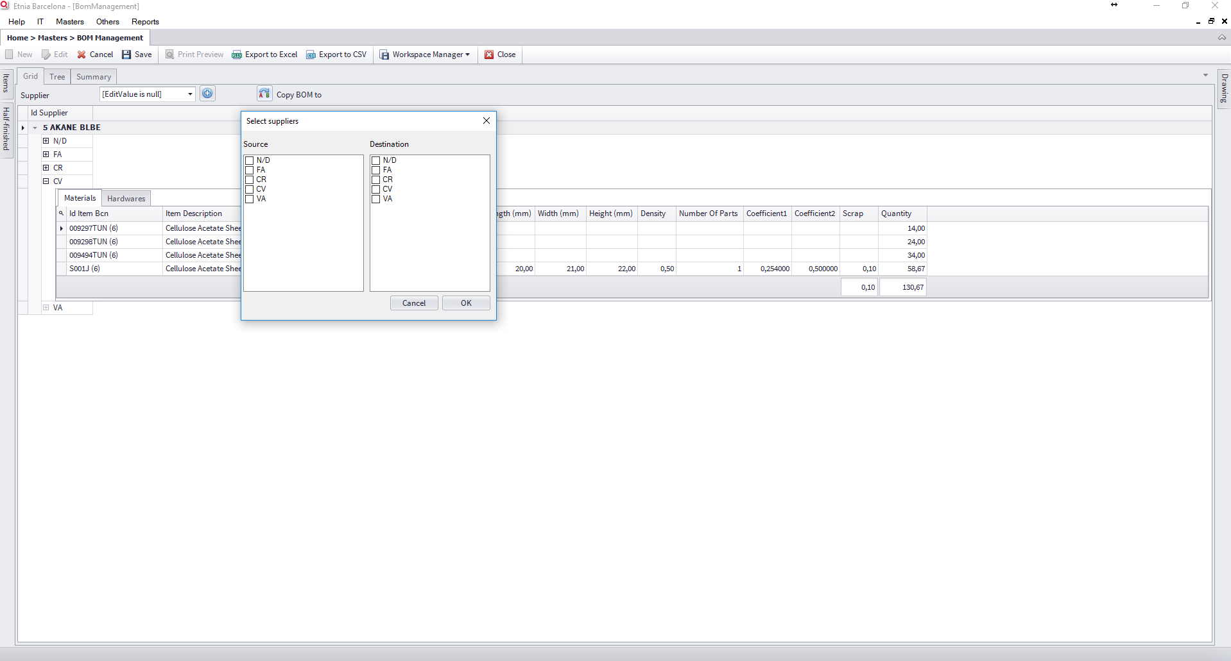

Figure 17:Copy BOM to

This action will delete all the destination supplier BOM and copy the BOM source, with the following considerations:

* Materials: Copy all data directly.
* Hardware: Copy all data directly.
* Half-finished: Search if exist a BOM for this half-finished (source) and supplier (destination), if exist it will be copied to destination, if not a warning message will be displayed.

In this example we are trying to copy “N/D” BOM to “SDS” BOM, but SDS hasn’t a BOM defined for these 3 half-finished.

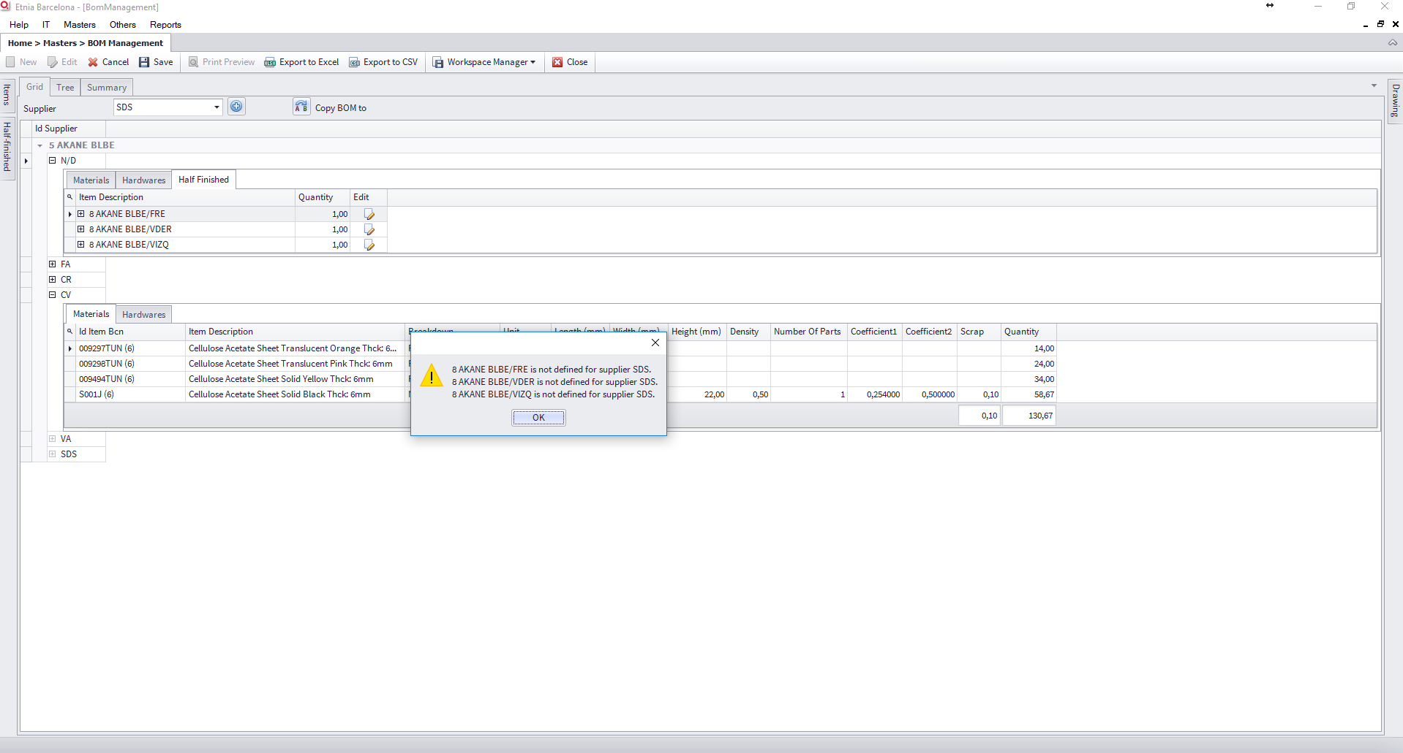

Figure 18:Copy BOM, warning message